GoodTime Inc.

Business Plan

December 2017

Ashton Soles

CEO & Founder

Goodtime

223 Ponte vedra Drive

Fayetteville, Georgia 30215

6788605642

asoles23@gmail.com

Executive Summary

Business Overview

Goodtime
Date of formation: 08-23-2017
C Corporation

Goodtime provides a unique planned and fuclitated date/ event experience.
We are a recreational event scheduler service based out of Atlanta,GA.
Our management team has the experience and expertise to successfully execute on our business plan.

Goodtime’s mission is to become the world's leading event/nightlife app while creating memorable experiences while driving local business.
Management Team Members

Name : Ashton Soles

  - Title: CEO & Founder

  - Background: Experienced Sales Manager with a demonstrated history of working in the telecommunications industry. Skilled in Event Planning, Microsoft Excel, Customer Service, Microsoft Word, and Sales. Strong sales professional with a Bachelor of Business Administration (B.B.A.) focused in Business, Management, Marketing, and Related Support Services from Florida A&M University.
Name : Josh Smith

  - Title: Vice President of Marketing

  - Background:

Name : Napoleon Robinson

  - Title: Vice President of Finance

  - Background:

Name : Preston Henderson

  - Title: Vice President of Technology
  - Background:

Name :

  - Title: Vice President of Operations
  - Background:
Application Layout
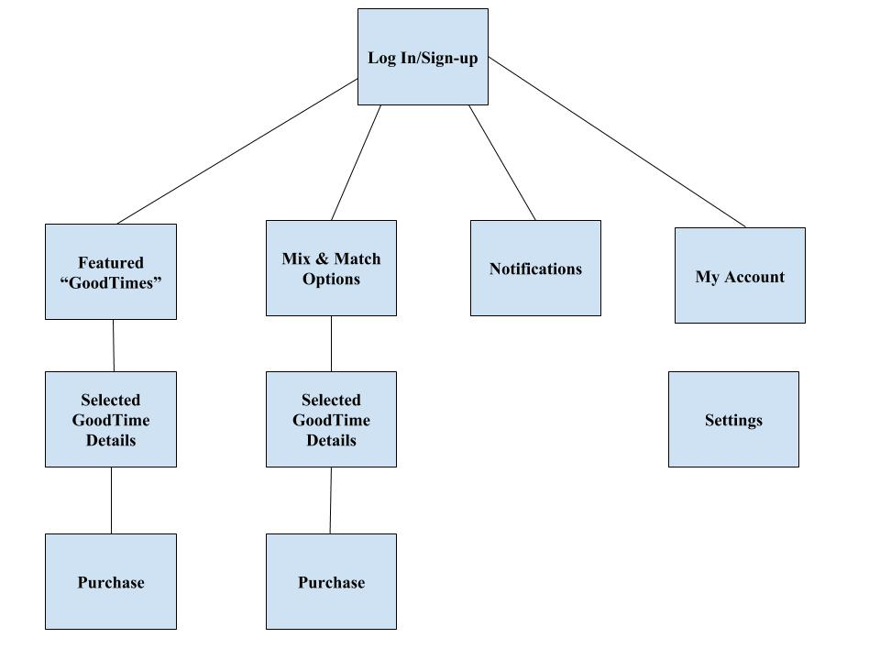Products, Services & Pricing

Product/Service #1 Name: Goodtime event

  - Product/Service benefits: Dates or connected events organized GoodTime user will be able to choose from different "Goodtime" Packages that will include multiple event nights for 2-6 people. These packages will include hand selected events that will create cultivated experiences.

  - Product/Service Price: $50-$500

Product/Service #2 Name: Goodtime Chauffeur

  - Product/Service benefits: Date night taxi allow users to enjoy the nights without the need to drive or remain sober.

  - Product/Service Price: $50-$100

Product/Service #3 Name: Date Adds ons

  - Product/Service benefits: Date adds-ons: Candy, Flowers, Pre-date Grooming

  - Product/Service Price: $50-$100

Product/Service #4 Name: Date In Home Options

  - Product/Service benefits: Date adds-ons: In-Home Chef, In-Massages

  - Product/Service Price: $50-$100

Industry Analysis

Industry Overview

Goodtime operates in the Nightlife and events market.

Total monetary sales in this industry last year: $24 Billion

Operators were in this industry last year: 100

Industry's key product and service segments: Food, Beverages, Nightlife

Key market trends: The industry will become more fragmented with a larger range of niche markets Rising consumer interest in higher-quality food and beverages will boost industry revenue The movement toward premium beverage consumption will benefit industry operators. The Restaurants & Leisure industry has experienced an 27% increase

Key market statistics: The Bars and Nightclubs industry has performed modestly over the past five years, as consumer confidence and overall spending have continued to steadily increase. Consumer drinking patterns have also changed during the period, forcing seasoned bar operators to adapt their menus to suit changing consumer tastes. Although industry revenue has fluctuated since 2012, due to steadily increasing consumer spending, growth has been inconsistent. This acceleration can be attributed to per customer spending surpassing previous levels. Much of the industry’s growth has been due to rising alcohol prices.

Relevant Market Size

Our relevant market size is the annual revenue that our company could attain if we owned 100% market share.

Our relevant market size is calculated as follows:
Number of customers who might be interested in purchasing our products and/or services each year? 10,000
Amount these customers might be willing to spend, on an annual basis, on our products and/or services? $1,000
Our relevant market revenue size: $10,000,000

As the analysis shows, our relevant market is large enough for our company to enjoy considerable success.

Competitive Analysis

Direct Competitors

- Direct Competitor #1: Groupon

- Direct Competitor #2: Eventbrite

- Direct Competitor #3: Date Night In.com

- Direct Competitor #4: Airbnb

Competitive Advantages

Goodtime is positioned to perform well based on superior products and service. Our company provides a unique experience unlike any services already out. This will allow us capture market share.
Location: Our location allows us to better serve customers because:
Our location in Atlanta also us to have prime access to individuals seeking entertainment activities.

Marketing Plan
The Goodtime Inc. Marketing plan will focus on the
Our marketing plan, included below, details our products and/or services, pricing, promotions plans and distribution strategy.

Customer Analysis

Target Customer

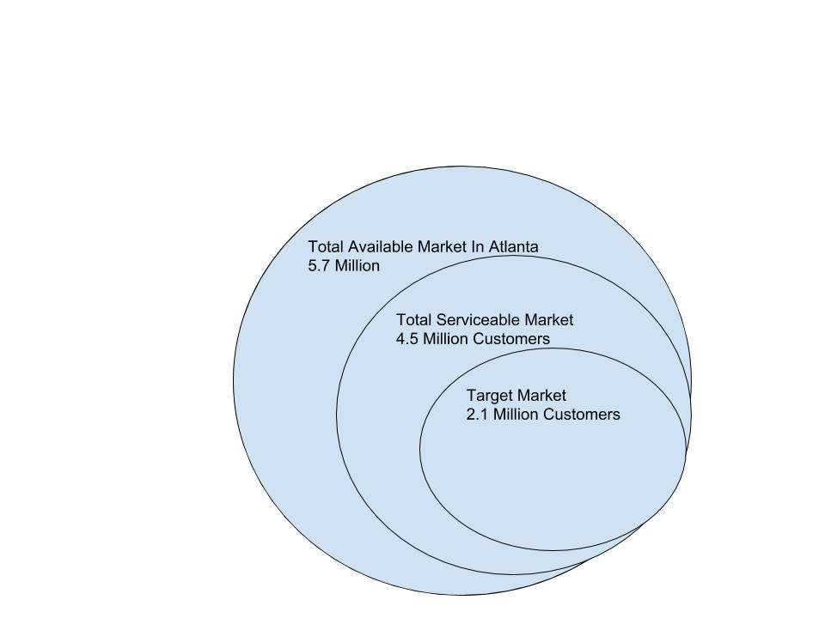

Age: 21-45

Marital Status: Single & Married

Education: Educated Professionals, Nightlifers, Young Adults

Activities & Interests: Art, culture, Music, Food, Skating, bowling, nature, wildlife, fitness

Promotions Plan

Goodtime will use the following tactics to attract new customers:

We will conduct surveys via social media to research favorite

Blogs, Podcasts, etc: Online and social media marketing i.e. Email Marketing:
Email blasted
Instagram, Facebook, Twitter

Flyers: Event
YELP, Eventbrite, Word of Mouth / Viral Marketing: Word of month, Twitter, Instagram, Snapchat,Facebook

Distribution Plan

Customers can buy from us via the following methods :

Company website: Goodtime.com

Company Phone: 6788605642

Distributors: Yelp

Operations Plan

Application Layout

Our Operations Plan details:

Key Operational Processes

The key day-to-day processes that our business performs to serve our customers are as follows:

Sales: Acquire partnerships with local vendors, restaurants and businesses for support users demand.

Marketing: Marketing the Goodtime app and website to drive user participation

Finance: Accurately account for business operations and adopt efficient pricing strategy to ensure profit.

Customer Service: Support customers thought use of the Goodtime Platform.

Milestones

The key business milestones that our company expects to accomplish as we grow include the following:

1. To Be Completed By : 2018-07-07

- Accomplishment #1: Launch Goodtime Application

- Accomplishment #2: Reach $10,000 in sales revenue 12/2018

- Accomplishment #3: Reach $50,000 in sales revenue

Financial Plan

Products, Services & Pricing

Product/Service #1 Name: Goodtime event

  - Product/Service benefits: Dates or connected events organized GoodTime user will be able to choose from different "Goodtime" Packages that will include multiple event nights for 2-6 people. These packages will include hand selected events that will create cultivated experiences.

  - Product/Service Price: $50-$500

Product/Service #2 Name: Goodtime Chauffeur

  - Product/Service benefits: Date night taxi allow users to enjoy the nights without the need to drive or remain sober.

  - Product/Service Price: $50-$100

Product/Service #3 Name: Date Adds ons

  - Product/Service benefits: Date adds-ons: Candy, Flowers, Pre-date Grooming

  - Product/Service Price: $50-$100

Revenue Model

Goodtime generates revenues via the following:

Sales of products/services:
"Goodtimes" will be planned date packages that are coordinated and assess with a 10%-35% service fee.

Ex. Based on cost for two people
Bowling $24
Restaurant Meal $30
Concert Tickets $50
Services Fee $15.60
Total Goodtime Cost: $119.60

Ex. Based on cost for two people
Flowers $35
Painting Class $25
Restaurant Meal $49
Helicopters Ride $135
Services Fee $36.60
Total Goodtime Cost: $280.60

Advertising sales: Listing fees

Financial Highlights

Year 1 Revenues: $$10000

Year 1 Net Income: $4,000

Year 2 Revenues: $30,000

Year 2 Net Income: $17,000

Year 3 Revenues: $90,000

Year 3 Net Income: $50,000

Year 4 Revenues: $300,000

Year 4 Net Income: $150,000

Year 5 Revenues: $1,000,000

Year 5 Net Income: $646,000

Funding Requirements/Use of Funds

Product Development & Operation:

Storage
Graphene DB $4800(annually)
- 8GB RAM
- 20GB storage

Website/Hosting Winhost $47.40(Annually)
- 3 GB Disk Space
- 50 GB Bandwidth
- 10 FTP Users
- 100 MB Site Memory
- 1 SQL Database
- 500 MB SQL & MySQL
Requirements Documents(Application):
What does this need to able to do
App Flow Chart

PayPal(Free)
Payments/POS

Marketing: $2,000

Product Manufacturing: $0

Staffing: $2,000

Rent: $0

Other: $2,000

Other is defined as: Services cost and fees

Exit Strategy

GOODTIME BUSINESS PLAN

We expect that investors will be able to cash out on their investment in our company via IPO.

We expect to achieve this goal by 2022.

Things to do?

1.Put out survey for list of things to do

Application Layout

1.Tab 1 Featured “GoodTimes”
Packages of “GoodTimes”(1-3 preselected events)
2.Tab 2 Mix & Match Options (1-3 selected events)
3.Tab 3 Notifications
4.Tab 4 My “GoodTimes”
5.Tab 5 POS(Paypal)

Success Factors

Goodtime is uniquely qualified to succeed due to the following reasons:

Products and/or Services: Our Products and/or Services are superior to our competitors because we provide a seamless platform for user to selection from numerous dates and event for their social enjoyment.
Location: Our location allows us to better serve customers because: Our GoodTime events with be located within the metro Atlanta area.

Marketing: We have unique marketing skill sets that enable us to attract new customers at a low cost These skill sets include: Goodtime competitive advantage involves tailed alternatives to the traditional nightlight experience

Customer Needs
Talk through the customer needs
Speed: Customers want to able to access events options quickly.
Quality: User want quality and unique experiences
Location: Major cities
Price: $50-$500
Convenience: Customers want to able to access events options quickly.

10

